**Monthly Claim Reporting Documentation**

1. **What is the report?**

The monthly report is saved at the Large Account folder, except Markquart Group. Here, we all call them dealers, but they are actually three different roles: dealer (individual dealer), dealer group, and lender. Take American Automotive Alliance Group for example, two files need to be generated each month.

The **Reserve Summary** comes from the Tableau file in External Reporting folder. Each month we save a copy of the Tableau dashboard for reporting purposes. Make sure the filter select the correct time period for the report. **File -> Print to PDF** and rename the pdf file with correct month and naming convention.

The **Claim Summary** is the pdf output of the Claim Detail Template. Each month, we print out the pivot tables for the dealer. The data come from this query **SQL Claims Detail with GWR_AULDATAMART_with Post Period_03-07-2020 (updated).sql**executed in **AULDATAMART** in **AUL-DB-30**. Since these two reports need to be sent out every month in the email, make sure the claim totals in both reports are the same.

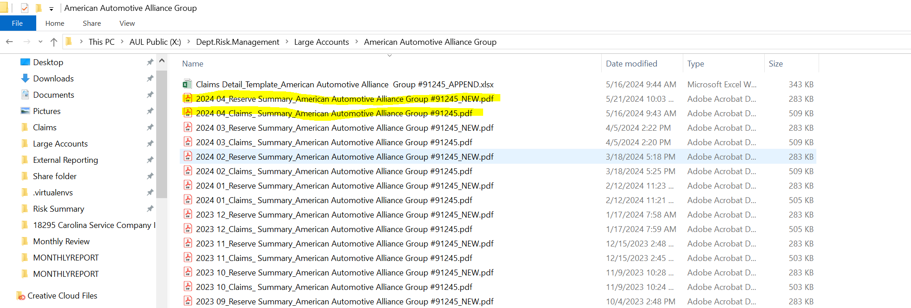

This small Python program automates the part of appending the new month’s data into the claim template for dealers, groups, and lenders if their monthly report contains the .xlsx claim file. It does not reconcile the difference between Tableau totals and the query result.

1. **Set Up**

Submit an IT ticket to install the following software in your AUL virtual machine:

* Visual Studio Code – The coding environment to run and edit Python code
* Python 3.12

Check **ADD TO PATH** when installing Python

Since this program is written in Python 3.12, Python in older versions may not work. To make sure required Python libraries in correct versions are installed in your environment, please:

1. After Python is successfully installed, open up command prompt from the start menu
2. Enter Python, you should see your Python version show up as below
3. After that, type quit(), and then “pip install pipenv”

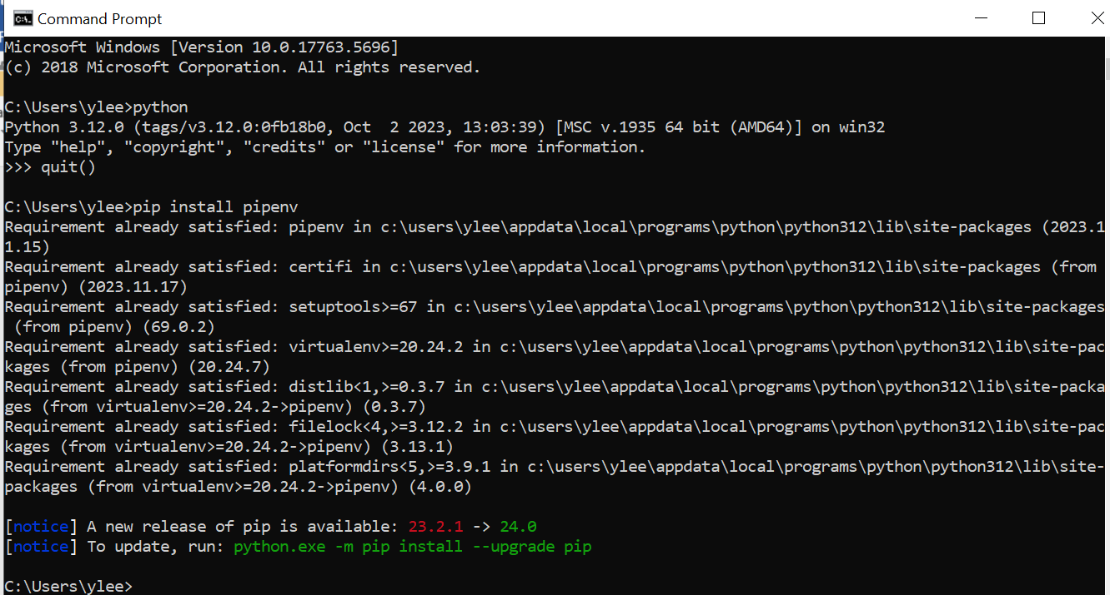

Pipenv is a Python library that manages the virtual environment. This Python program is written with specific Python packages that can be found in the pip file

1. Go to X:\Dept.Risk.Management, copy the **dev** folder to your C drive.
2. In your command prompt, enter “cd C:\dev\MONTHLYREPORT” to change directory to MONTHLYREPORT folder. Then, enter “pipenv install”
3. **To kick off the run for each month in your command prompt:**
4. Make sure you have change directory to C:\dev\MONTHLYREPORT so the virtual environment can be picked up. If not, “cd C:\dev\MONTHLYREPORT”
5. The command looks like **pipenv run python main.py run YYYY MM**

For example, “pipenv run python main.py run 2024 05”. YYYY is the report year and MM is the reporting month.

1. The reports will finish and be saved in C:\dev\MONTHLYREPORT\etl
2. **Reconcile the number**

New month’s files will be saved in **etl** folder. Make sure the number is correct before moving them to Large Accounts folder because we do not want to overwrite the previous month’s workbook with a wrong number. There is no backup of the .xlsx for each month. After new month’s data is appended, manual validation for the total claim number is still required. Make sure the report date in the first page of the pivot table is updated with the current report month. Refresh the pivot table, and reconcile the number against the ClaimPaid_ITD in Tableau. Try to align Excel’s number to Tableau’s number.

If both numbers from Tableau and Excel look right, here is the email template for some of the dealers: X:\Dept.Risk.Management\dev\MONTHLYREPORT\emails Use them as template and attach the new month’s file.

1. **Extra details about the code**

* **etl** folder
* **instruction.json** stores all the information for each dealer that needs the claim report.

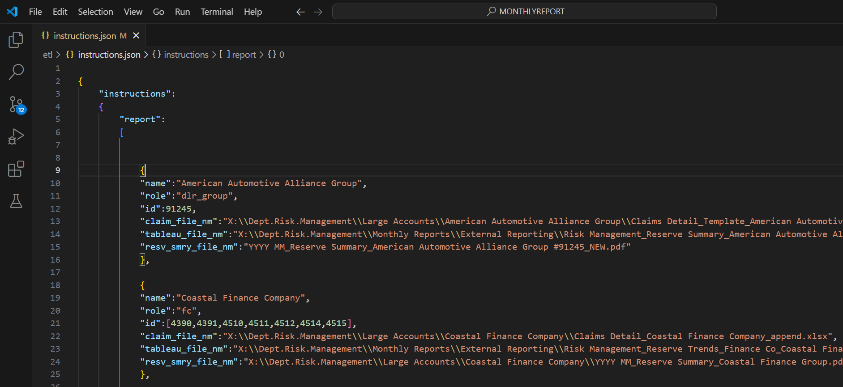

* + **SQL Claims Detail with GWR_AULDATAMART_with Post Period_03-07-2020 (updated).sql**

Same as the code that is in the share folder except the variable declaration at the very top is removed. Python code would rebuild the variables.

* **main.py** is the program that packages everything together
* **monthlyreport** (lowercase)folder
  + **Query.py** contains three functions that are imported into **ReportRunner.py**.
  + **__init__.py** wrapseverything up in the monthreport folder so **main.py** can import them all at once.